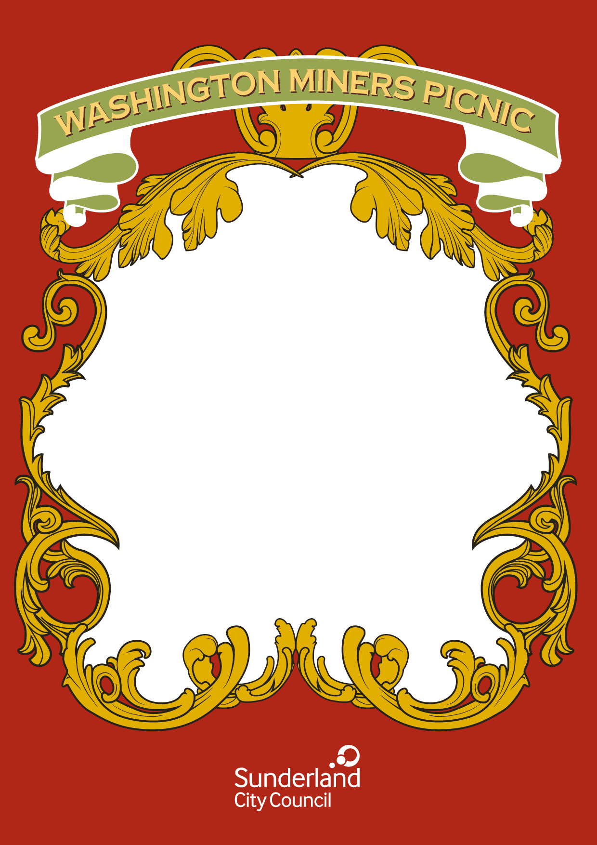

**Washington Millennium**

**Centre**

**Monday 29th July**

10.00    Cllr Kelly will open the Miners Exhibition in the Library

10.15    Washington History Society Photographic Exhibition

10.30    Tyne & Wear Archives Mining Object Handling Session

2.30 Local Banner Groups sharing stories

**Tuesday 30th July**

10.30    Bowes Railway, Wilf Brown: The History of Usworth Colliery

11.30    Miners Lamps and their History

4.30 The history of the banners with Kevin Roddy

**Wednesday 31st July**

10.30    Beamish Museum Pit Village life and Handling Session

5.30    Washington History Society "sent in wi’ the big lads" - Jim Tatters

memoires

**Thursday 1st August**

10.00    Sharing Stories and Memories Washington Trust

11.30    Display of Schools Art Work (A Miner at work)

**Friday 2nd August**

10.00    Usworth Miners Show and Tell Session Les Simpson

11.00    Art Collections from George Westgarth.